
Summer is fast approaching and whether you are going to the beach 
Home Safety
Summer Vacation Checklist
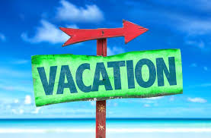
DAVID S. YOUNG
CHIEF OF POLICE

for the day or away for the week, here are some good safety tips to secure your home, cars 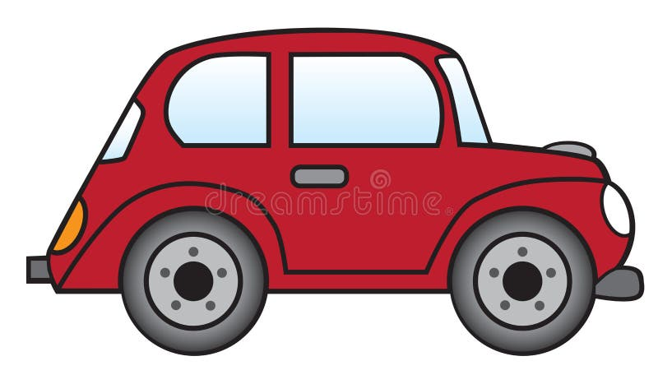and valuables.
________________________________________________

___ 1. Put a hold on mail and newspapers delivered to our home.

___ 2. Re-schedule any Amazon deliveries or automatic deliveries (ie, Chewy).

___ 3. Pay any necessary bills, ie. sewer, water, gas, electric.

___ 4. Notify your alarm company if you have a home alarm.

___ 5. Go to the Police Department website (whartonpolice.com) and fill out the vacation home check form (More Info Tab) to request a property check while you are away.

___ 6. Lock all windows and doors. (Upstairs too!)

___ 7. Put a safety bar or 2x4 on sliding glass doors for extra safety.

___ 8. Use timers on lights. (Be clever, put the timer to turn off the downstairs light at 10:00pm and the bedroom light to go on at 10:01 pm)

___ 9. Let your neighbors know you will be away and ask them to keep an eye on your property. Ask them to put out trash out on trash day. Consider leaving a key with a trusted neighbor in case of an emergency.

___ 10. Close your blinds and curtains.

___ 11. Adjust your thermostat.

___ 12. Mow your lawn or ask someone to keep up your yard.

___ 13. Turn off the water to the washing machine to prevent any issues.

___ 14. Leaving pets at home? Make sure to leave instructions.

___ 15. Parking a car at the airport? Consider removing your insurance card and registration with your home address on it out of the glove box. Don’t give house or work keys to an attendant, just the car key.

___ 16. Remove all garage door openers from cars.

___ 17. Lock up any ladders you have in your yard.

___ 18. Remove all outside items to avoid them being stolen.

___ 19. Don’t leave a hidden key outside.

___ 20. Remove or secure all guns and ammunition.

___ 21. Make sure Ring Camera batteries are charged.

___ 22. Check all smoke and carbon monoxide alarms are in working order.

___ 23. Have a will? Leave it with your attorney or family member.

___ 24. Unplug unessential electronics/appliances.

___ 25. Secure your checkbook, credit cards, other documents, cash, valuables and jewelry you are not taking with you.

